GRIFFIN MEETING MINUTES MODULE - QA TEST REPORT
No. | Section | QA Test Result | QA Comments | Reference | Remarks
1 | Add New | Passed | All options have been tested and confirmed to be fully functional. | N/A
2 | Meeting Details | Passed | All options have been tested and confirmed to be fully functional. | N/A
3 | Notes | Passed | All options have been tested and confirmed to be fully functional. | N/A
4 | Meeting Minutes Home Page | Passed | - After saving the inputs, they already appeared on the Home Page even after refreshing it.  - Additionally, no data contamination occurred in the Main Account. | 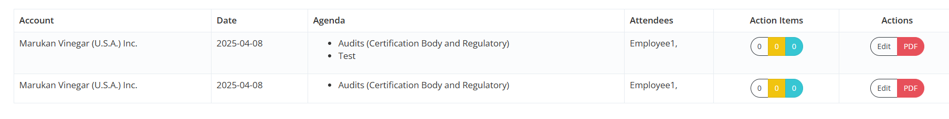 | Resolved - 20250408
5 | Action Items Section | Passed | All options have been tested and confirmed to be fully functional. | NA
6 | Action Section | Pending | It has not been tested yet, as the drafted meeting minutes were not saved. | NA
7 | Reference | Pending | It has not been tested yet, as the drafted meeting minutes were not saved. | NA
8 | Main Switch Account | Pending | It has not been tested yet, as the drafted meeting minutes were not saved. | NA
9 | Paramount Switch Account | Pending | It has not been tested yet, as the drafted meeting minutes were not saved. | NA

QA Test Performed by:
Debbie M. Abangan (April 2, 2025)

